**#3. Write a program to implement Informed search techniques: Greedy Best First Search.**

from queue import PriorityQueue

v = 14

graph = [[] for i in range(v)]

# Function For Implementing Best First Search

# Gives output path having lowest cost

def best_first_search(actual_Src, target, n):

visited = [False] * n

pq = PriorityQueue()

pq.put((0, actual_Src))

visited[actual_Src] = True

while pq.empty() == False:

u = pq.get()[1]

# Displaying the path having lowest cost

print(u, end=" ")

if u == target:

break

for v, c in graph[u]:

if visited[v] == False:

visited[v] = True

pq.put((c, v))

print()

# Function for adding edges to graph

def addedge(x, y, heuristic):

graph[x].append((y, heuristic))

graph[y].append((x, heuristic))

# The nodes shown in above example(by alphabets) are

# implemented using integers addedge(x,y,heuristic);

addedge(0, 1, 3)

addedge(0, 2, 6)

addedge(0, 3, 5)

addedge(1, 4, 9)

addedge(1, 5, 8)

addedge(2, 6, 12)

addedge(2, 7, 14)

addedge(3, 8, 7)

addedge(8, 9, 5)

addedge(8, 10, 6)

addedge(9, 11, 1)

addedge(9, 12, 10)

addedge(9, 13, 2)

source = 0

target = 9

best_first_search(source, target, v)

**Input:**

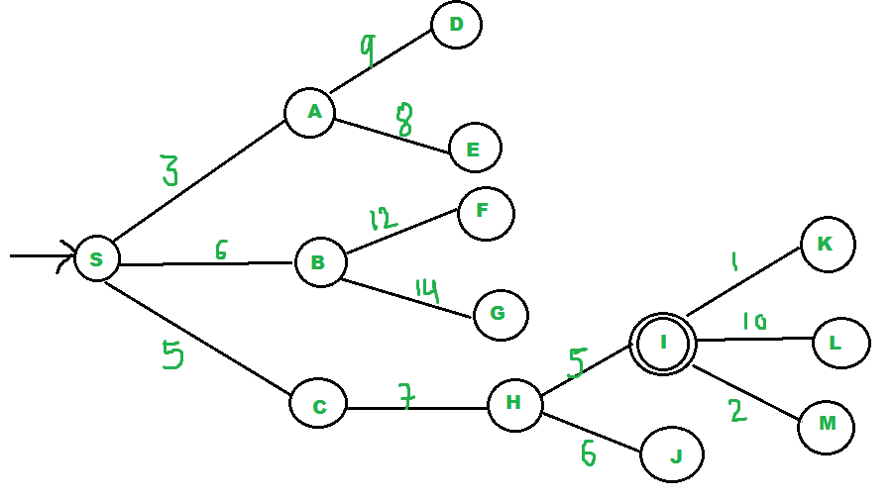

**Output:**

**0 1 3 2 8 9**